1.
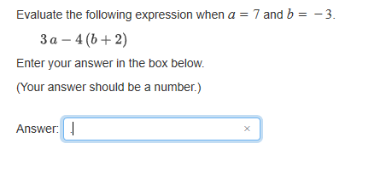

Answer: 25

2.
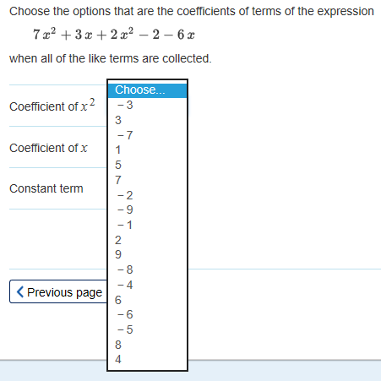

Q 2 Answer:
Coefficient of x² : 7, 2
Coefficient of x: 3, -6
Constant term: -2
3.
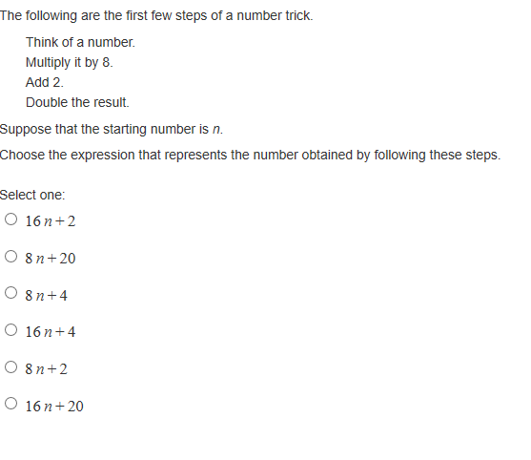
Answer: 16n +4

4.
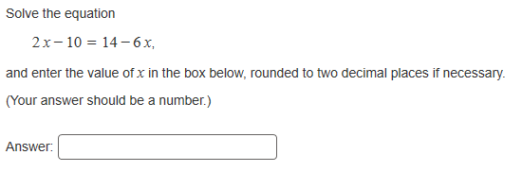
Answer: 3
5.
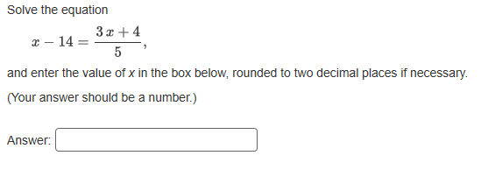
Answer: 37
6.
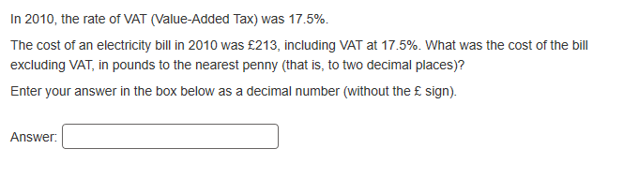
Answer: 181.28
7.

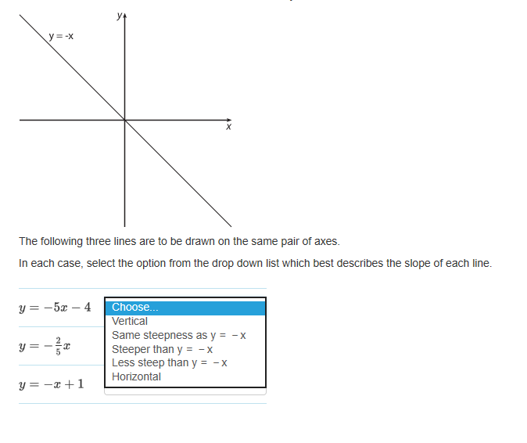
Answer
Y=-5x-4: Steeper than y= -x
Y= -2x/5: less steep than y= -x
Y= -x + 1: Same Steepness as y = -x
8.
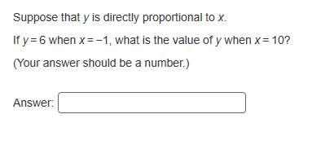
Answer: - 60
9.
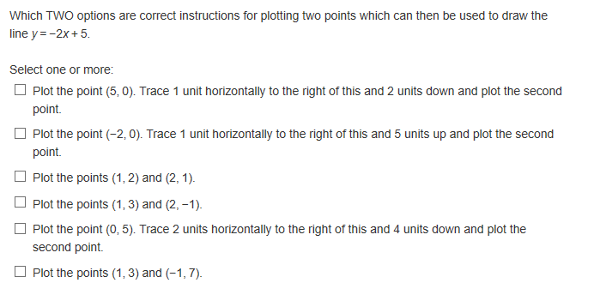
Answer:
Plot the point (0, 5), Trace 2 units horizontally to the right of this and 4 units down and plot the second point
Plot the points (1,3) and (-1, 7)
10.
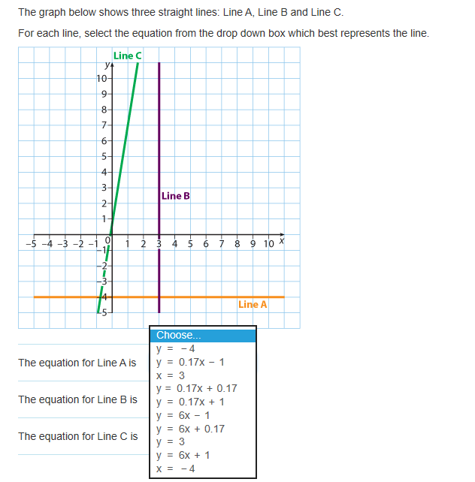
Answer
The equation for Line A is y = - 4
The equation for Line B is x = 3
The equation for Line C is y = 6x + 1
11.

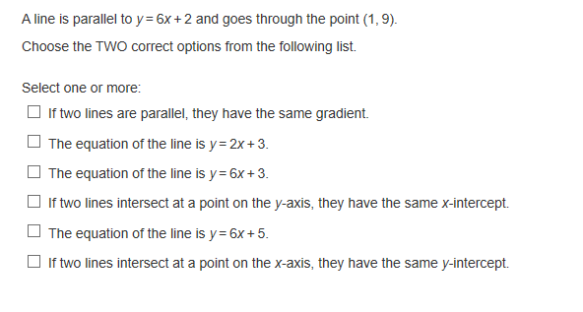
Answer:
If two lines are parallel, they have the same gradient
The equation of the line is y = 6x + 3
12.

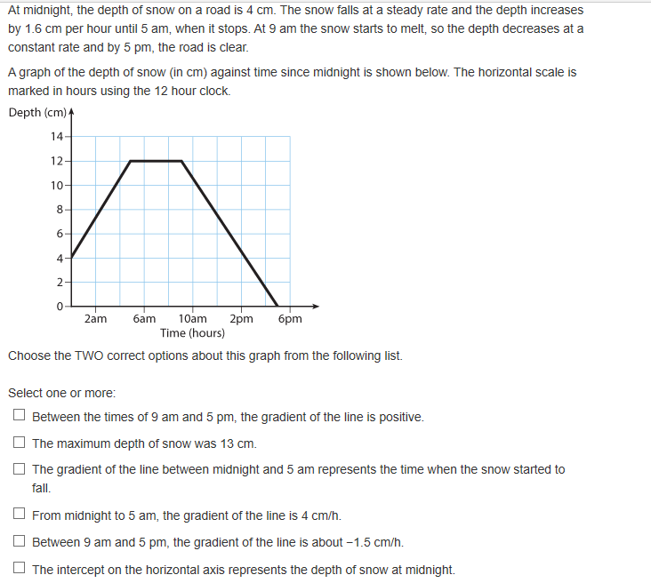


Answer
The line is horizontal between the times of 5 am and 9 am
13.
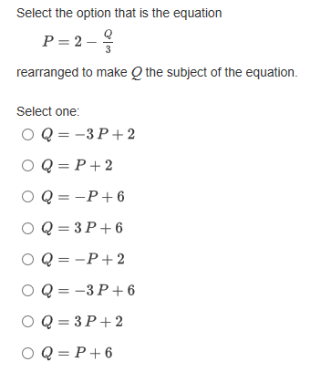

Answer: Q = -3 P + 6
14.
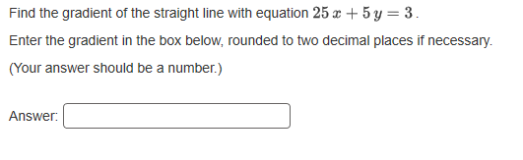
Answer: - 5
15.
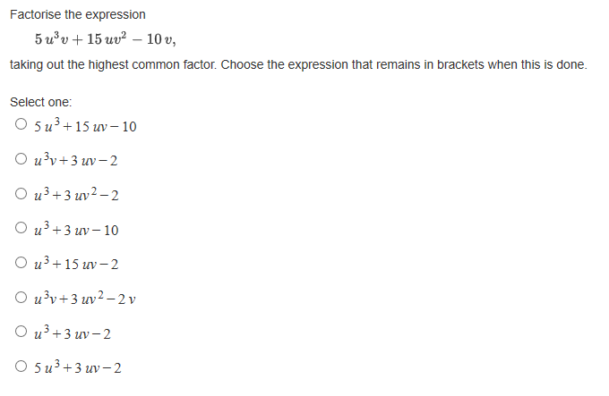
Answer: U³ + 3 uv - 2
16.
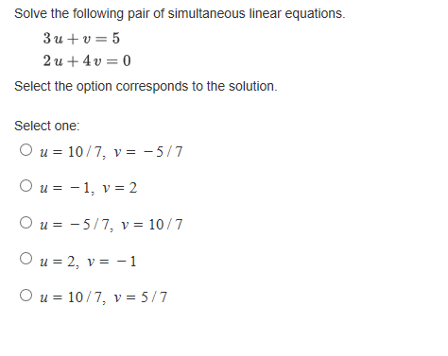
Answer: u= 2, V= -1
17.
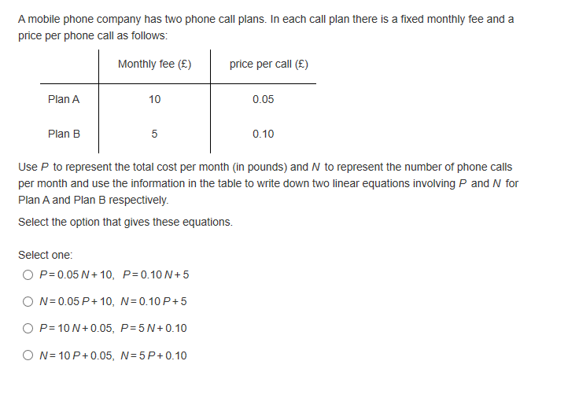
Answer: P= 0.05 N + 10, P= 0.10 N + 5
18.
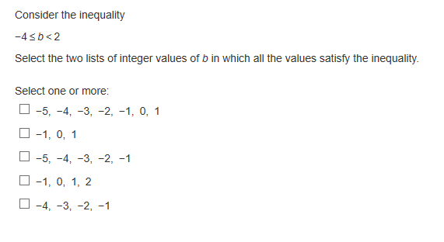
Answer:
-1, 0, 1
-4, -3, -2, -1

